Week5: ACF Lab 5: RDS lab

Dang Khoa Le
Student ID: 103844421
Major: Bachelor of Software Engineering
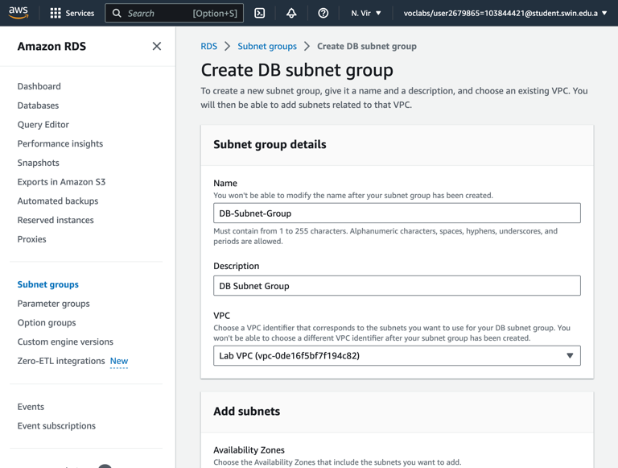

Abstract— This document presenting the demonstration for Week 5 – Lab 5: RDS lab. The demonstration is based on AWS academy infrastructure.

I. Task 1: Create a Security Group for the RDS DB Instance:
The following images illustrate Task 1, creating a security group with Lab VPC and MYSQL/Aurora(3600) inbound rule and sourced from Web Security Group.
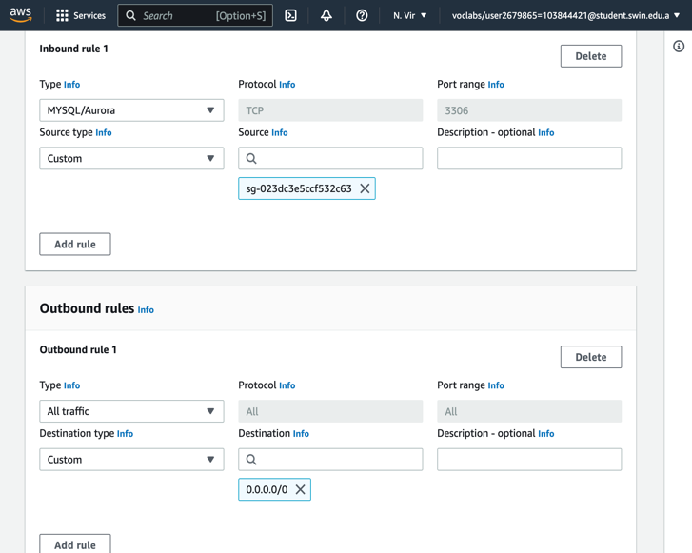
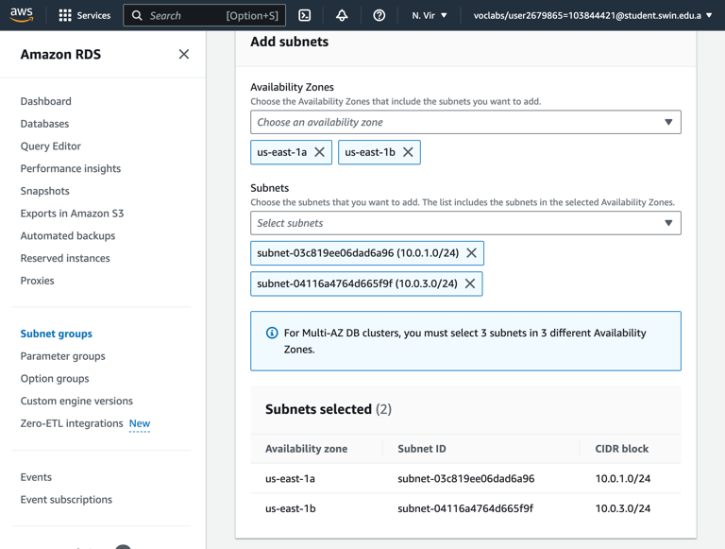
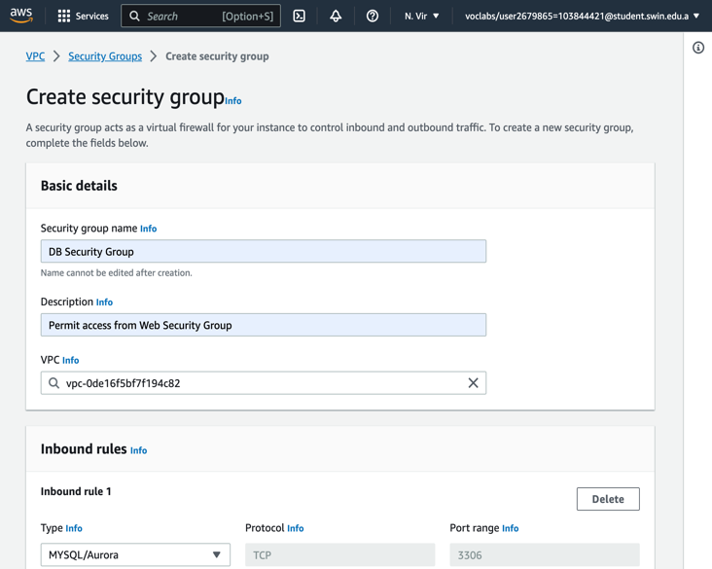
II. Task 2: Create a DB Subnet Group:
The following images illustrate Task 2, creating a DB Subnet Group.
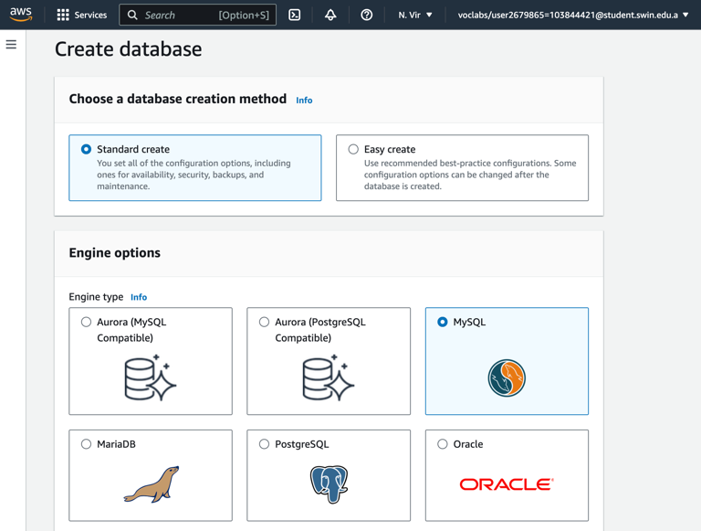
II. Task 3: Create an Amazon RDS DB Instance:
The following images illustrate Task 3, create an Amazon RDS DB Instance.
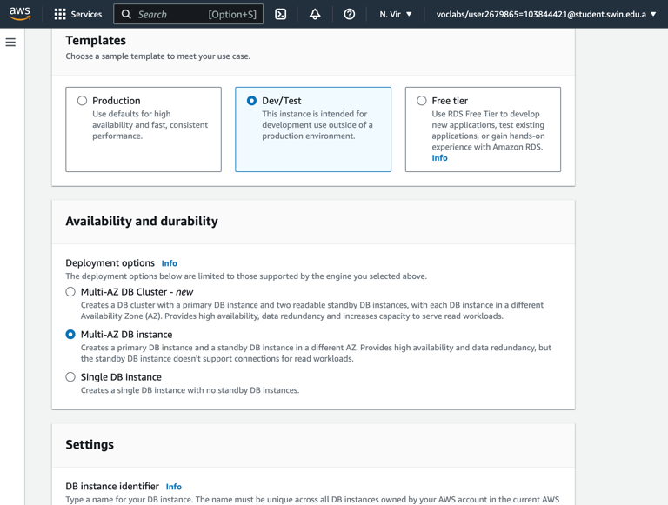
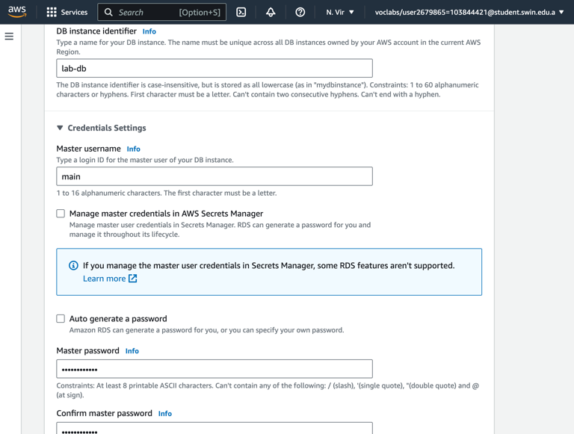

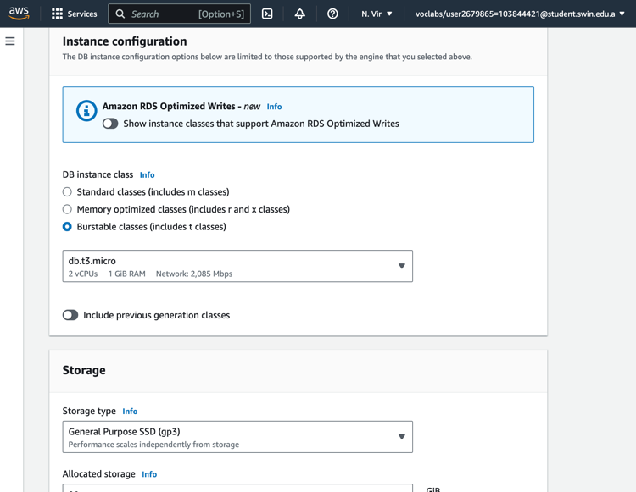

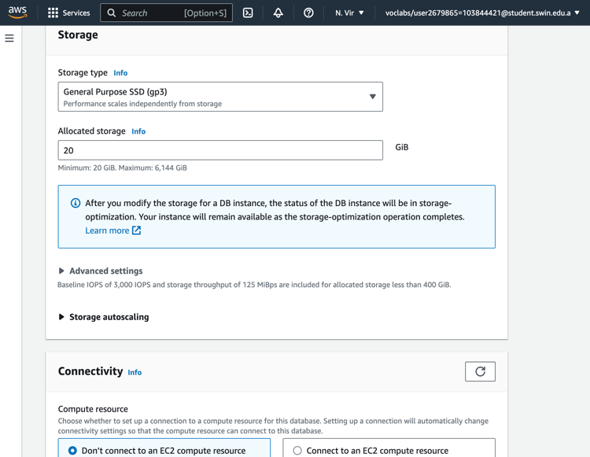

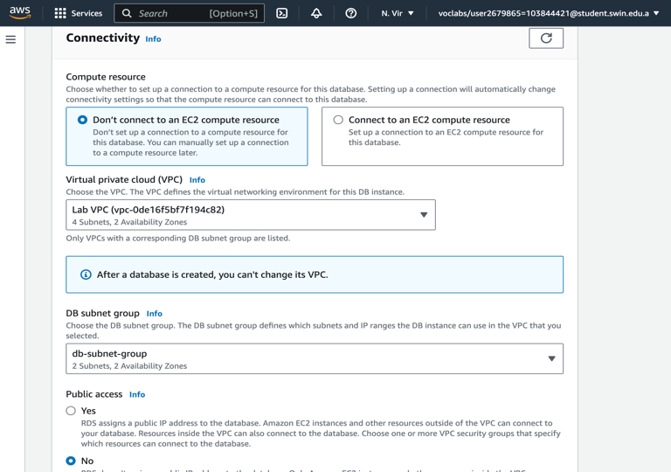

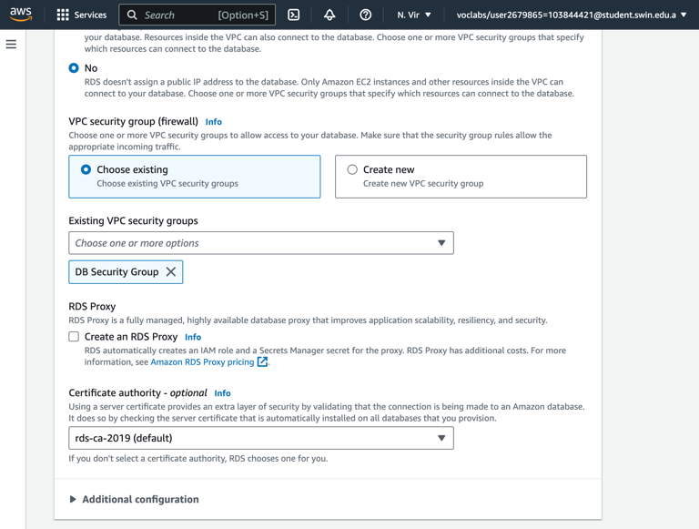

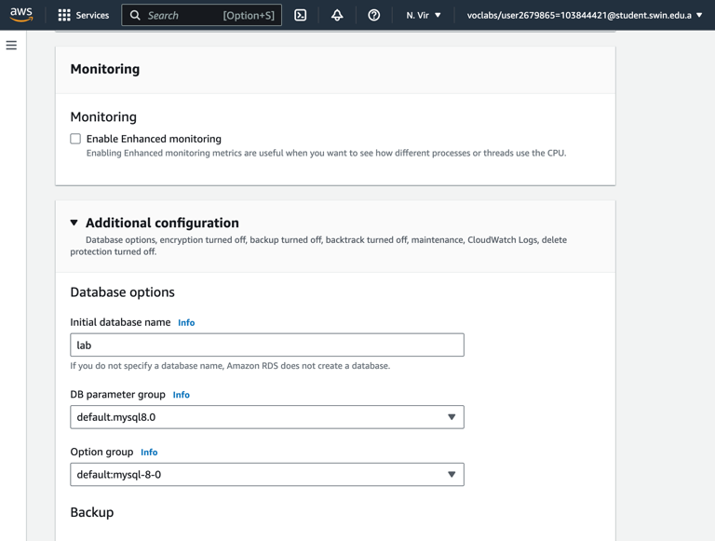

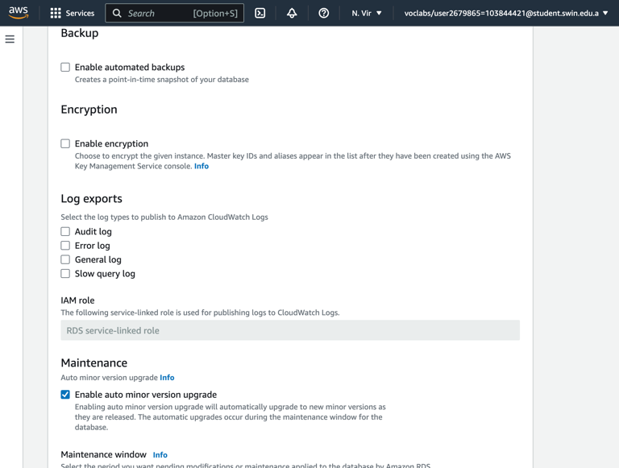

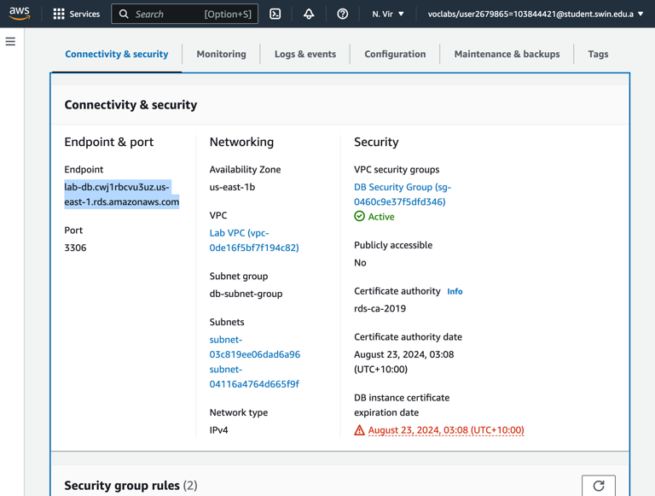

IV. Task 4: Interact with Your Database:
The following images illustrate Task 4, interacting with the database on web browser.
